11.62: A and B are straightforward, the tensions being the weights suspended; To find 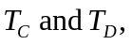a trick making use of the right angle where the strings join is available; use a coordinate system with axes parallel to the strings. Then, To find 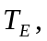 take torques about the point where string F is attached;
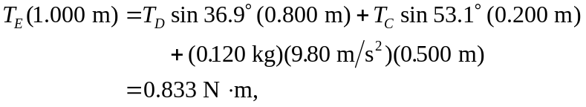
so 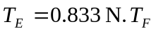 may be found similarly, or from the fact that 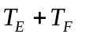must be the total weight of the ornament.

